Fall 2024
WEEK | SUN | MON | TUES | WED | THURS | FRI | SAT
9 | 20 | 21 | 22 | 23 Sukkot Ends | 24 | 25 | 26 USC vs Rutgers
10 | 27 | 28 | 29 | 30 | 31 Halloween | NOVEMBER  1 Diwali | 2 USC @ Washington
11 | 3 Daylight Savings Time Ends | 4 | 5 Election Day | 6 | 7 | 8 | 9
12 | 10 | 11 Veterans Day | 12 | 13 | 14 | 15 Last Day to drop with a W | 16 Homecoming USC vs Nebraska
13 | 17 | 18 | 19 | 20 | 21 | 22 | 23 USC @ UCLA
14 | 24 | 25 | 26 | 27 Thanksgiving Break | 28 Thanksgiving Day Break | 29 Thanksgiving Break | 30 USC vs Notre Dame
15 | DECEMBER  1 | 2 | 3 | 4 | 5 | 6 Classes End | 7 Study Days
16 | 8 Study Days | 9 Study Days | 10 Study Days | 11 Finals Begin | 12 | 13  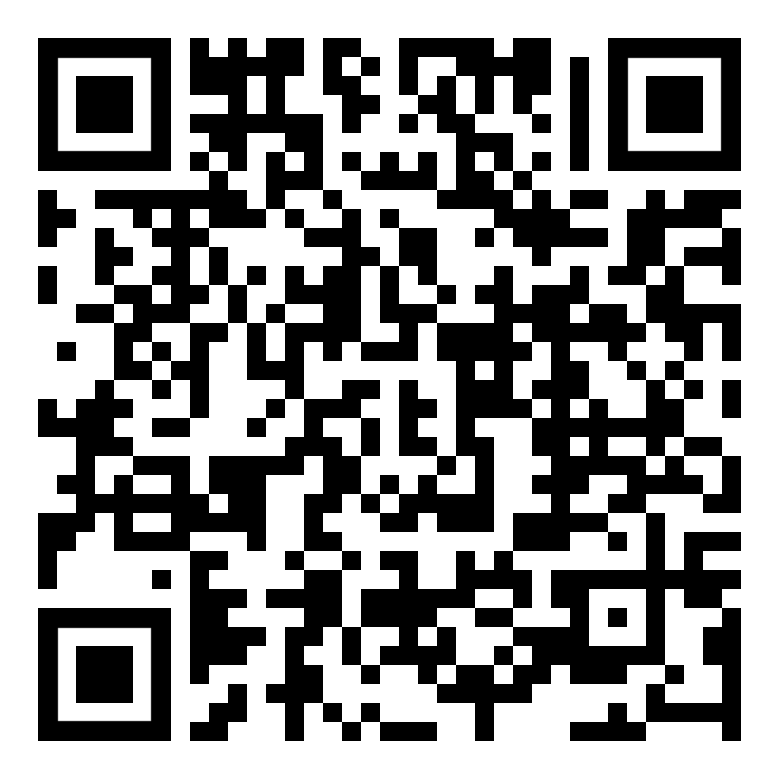 | 14
17 | 15 | 16 | 17 | 18 Finals End | Winter Break (Until Jan 12th)
How to Create a Semester Calendar QR code

