Chronotypes & Sleep Schedule

Each of us has a unique biological rhythm that affects not only how and when we sleep, but also our creativity, productivity, and even our personality. Discover your chronotype and how to harness it to build a happier, healthier life (Calm, 2023). 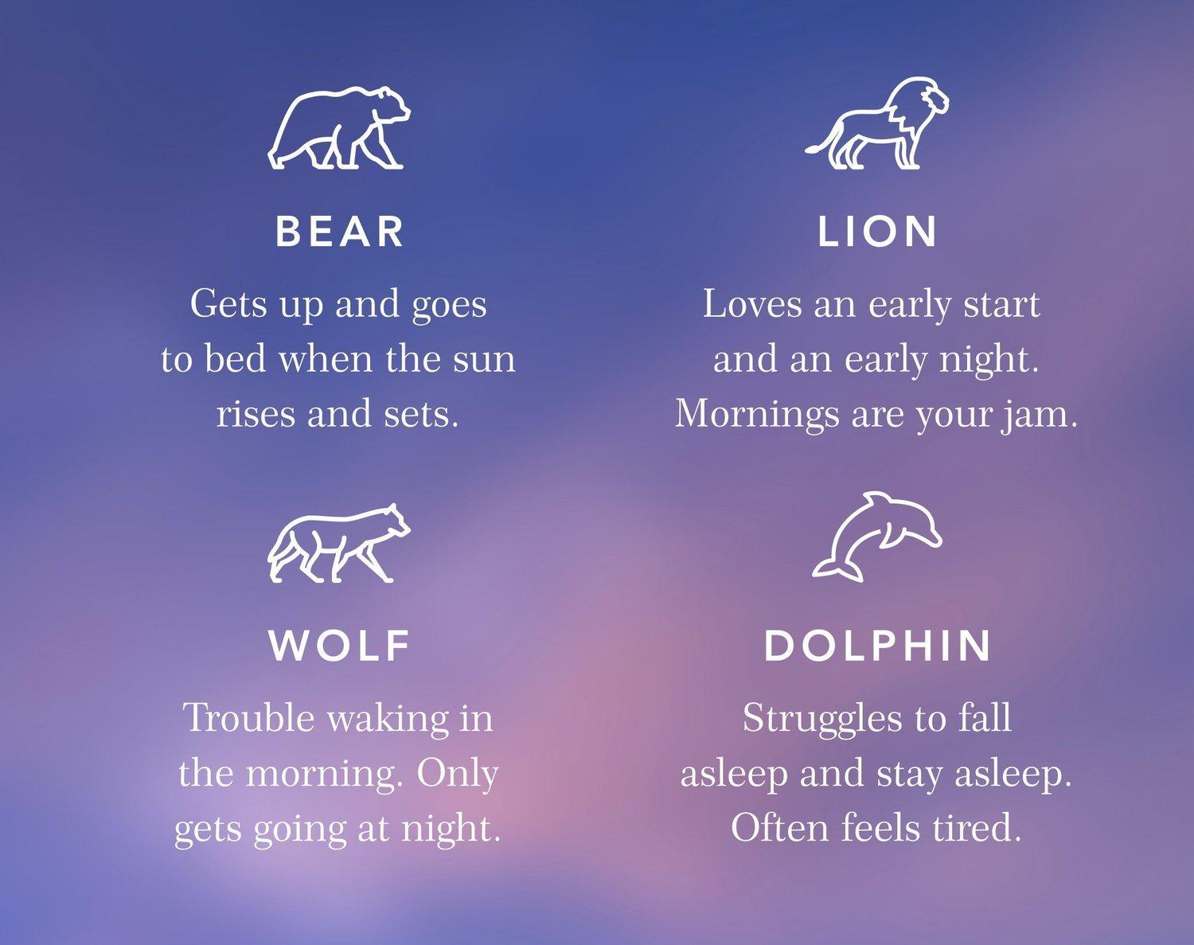
Illustration: Calm. (2023, March 26). What Your Chronotype Says About Your Sleep Patterns, Productivity & Personality. Calm. https://blog.calm.com/blog/sleep-chronotypes

What is a Chronotype?
A chronotype is your body’s natural disposition to be awake or asleep at certain times. Your chronotype is closely related to your body’s circadian rhythm, which controls your body’s sleep-wake cycle and melatonin production. Light exposure primarily influences our circadian rhythm and tends to rise and set with the sun. This means less melatonin is produced in the morning to help you wake up, and more is produced during the evenings to help you fall asleep (Breus, 2016).

Fun Fact: Your chronotype can change with age, and that’s normal. Most kids wake up and sleep early, but this will change as they grow into adolescence. This will change again as they reach adulthood.

Why are Chronotypes Important?
Knowing your chronotype can help you:
- Discover and improve your sleep quality and quality of life (Pacheco, 2023).
- Schedule your day’s work and study time around your productivity windows (Breus, 2022).
- Gain valuable insights into your mind and body, it can also empower you to rethink the way you schedule your days (Calm, 2023).

If you’re consistently experiencing poor sleep even with the full night’s sleep, you may be working against your chronotype.

What are the Four Chronotypes?
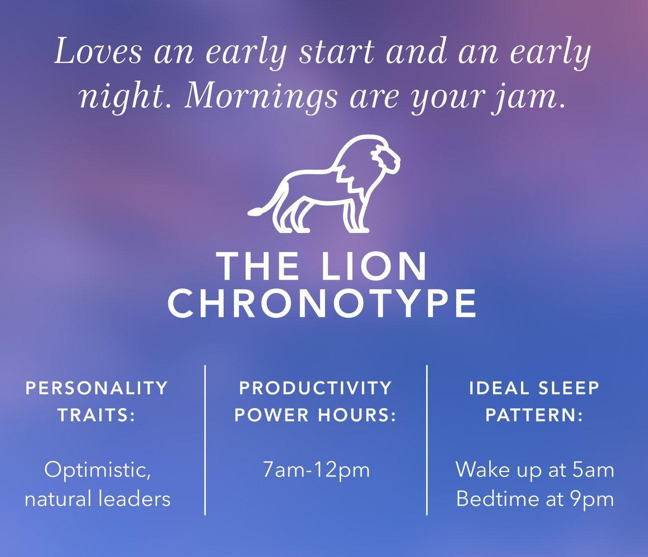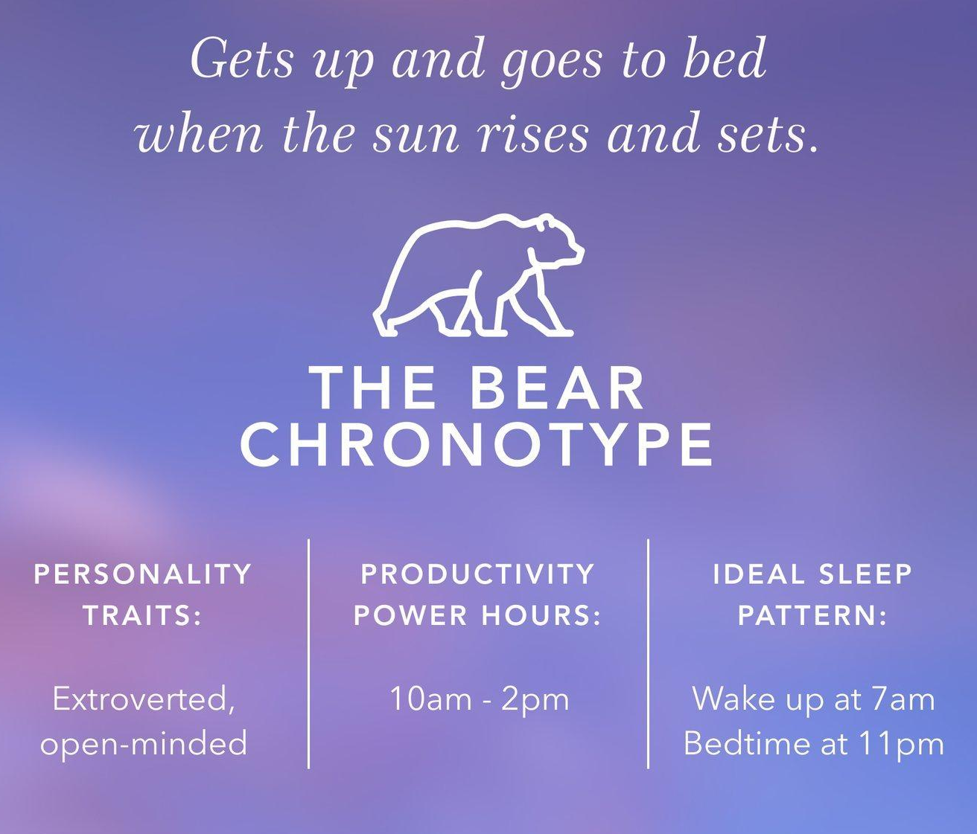
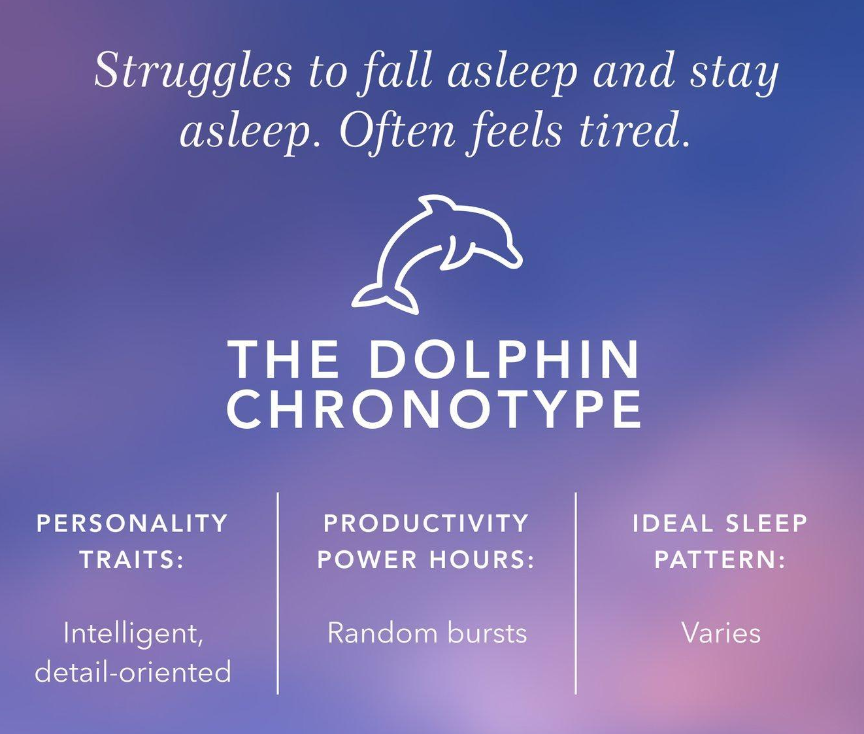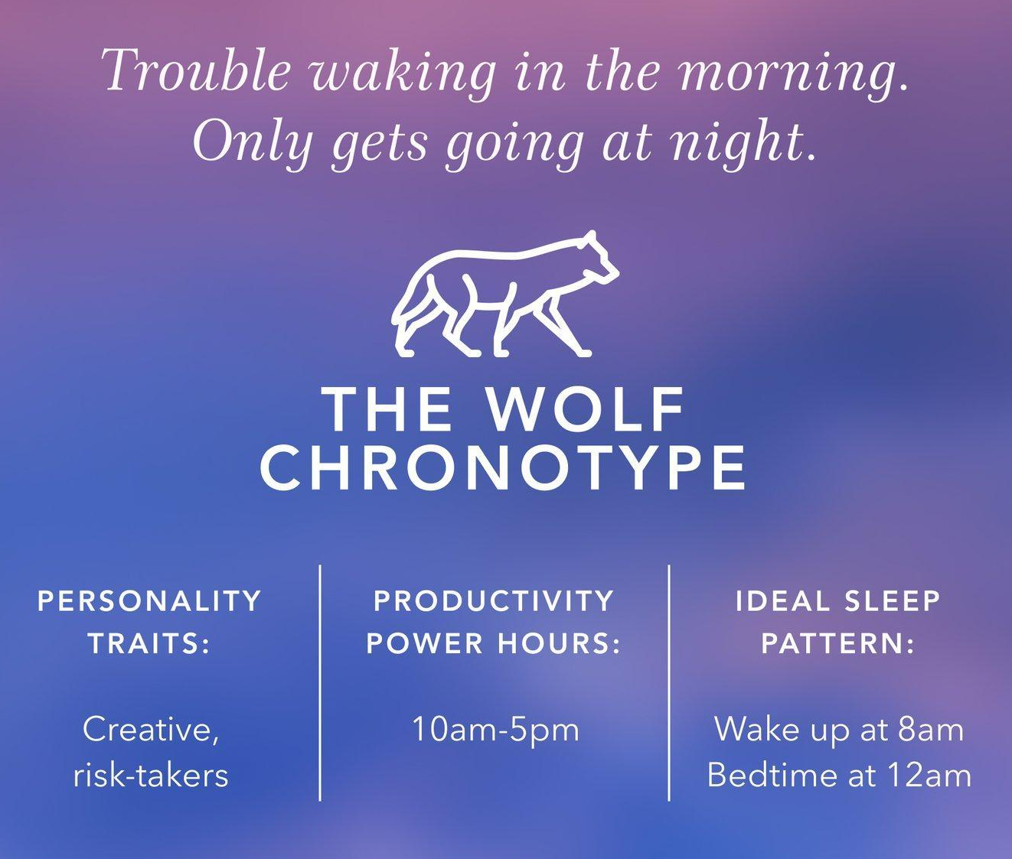
Illustrations: Calm. (2023, March 26). What Your Chronotype Says About Your Sleep Patterns, Productivity & Personality. Calm. https://blog.calm.com/blog/sleep-chronotypes
More Tips for Sleep Quality
Our sleep needs change as we age, and we might find ourselves in the transitional phase where our body’s clock may be a little skewed. If you are in-between chronotypes or struggling with your sleep, try the following to get the sleep quality and quantity you need to optimize your day (Breus, 2022).

- Regular Eating Schedule
Breakfast: Eating a high-protein breakfast can help boost your body and give you the energy you need for the day.
Dinner: An early, carb-heavy dinner is ideal to prepare your body for sleep. This will give your digestive system enough time before you wind down.

- Avoid Caffeine 6 Hours Before Bedtime
Consuming caffeine within six hours of your bedtime can disturb your rest. You can try avoiding caffeinated beverages at least six hours before your scheduled bedtime.

- Regular Sleep Schedule
A regular sleep schedule makes a big difference in your sleep quality.

Important: If you still struggle sleeping after adjusting to your chronotype or trying the tips for sleep quality, contact a sleep expert to see your potential treatment options.

What is my Chronotype?

You can take a quiz to discover which Chronotype best fits you.

Link & QR code to the quiz are provided below:
Sleep Quiz from The Sleep Doctor

Changes to Implement

Now that you know your chronotype, what changes could you make to your daily routines to increase productivity and energy? Use this space below to plan out changes that you would like to implement.

References
Breus, M. (2022, December 13). Chronotypes. The Sleep Doctor. https://thesleepdoctor.com/how-sleep-works/chronotypes/
Breus, M. (2016, September 13). The Power of When. Little, Brown Spark.
Calm. (2023, March 26). What Your Chronotype Says About Your Sleep Patterns, Productivity & Personality. Calm. https://blog.calm.com/blog/sleep-chronotypes
Pacheco, D. (2023, March 2). Chronotypes. Sleep Foundation. https://www.sleepfoundation.org/how-sleep-works/chronotypes
Illustration Reference
Calm. (2023, March 26). What Your Chronotype Says About Your Sleep Patterns, Productivity & Personality. Calm. https://blog.calm.com/blog/sleep-chronotypes

