Summer 2023
WEEK | SUN | MON | TUES | WED | THURS | FRI | SAT
1 | MAY 14 | 15 | 16 | 17 1st Summer Session Begins | 18 | 19 | 20
2 | 21 | 22 | 23 | 24 | 25 | 26 | 27
3 | 28 | 29 Memorial Day | 30 | 31 | JUNE 1 | 2 | 3
4 | 4 | 5 | 6 | 7 | 8 | 9 | 10
5 | 11 | 12 | 13 | 14 | 15 | 16 | 17
6 | 18 Father’s Day | 19 Juneteenth | 20 | 21 | 22 | 23 | 24
7 | 25 | 26 | 27 1st Summer Session Ends | 28 2nd Summer  Session Begins | 29 Eid al-Adha | 30 | JULY 1
8 | 2 | 3 Independence Day (observed) | 4 Independence Day | 5 | 6 | 7 | 8
9 | 9 | 10 | 11 | 12 | 13 | 14 | 15
10 | 16 | 17 | 18 | 19 | 20 | 21 | 22
11 | 23 | 24 | 25 | 26 | 27 | 28 | 29
12 | 30 | 31 | AUGUST 1 | 2 | 3 | 4 | 5
13 | 6 | 7 | 8 Classes End | 9  Note: Fall Classes begin Aug 21

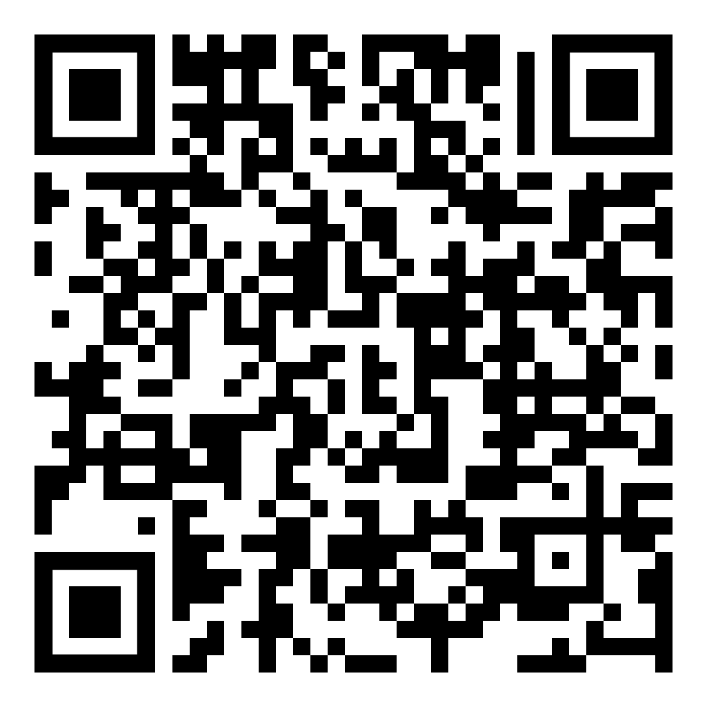
How to Create a Semester Calendar QR code

