Flowtime Study Technique
Flowtime Study Technique, created by Zoe Read-Bivens, is designed to take advantage of periods of time when you are fully immersed in a task. This period of full immersion, when you are highly productive and your ability to stay focused and engaged is effortless is referred to as flow state or simply flow. This occurs when the level of challenge and the level of ability are balanced, and productivity is high.
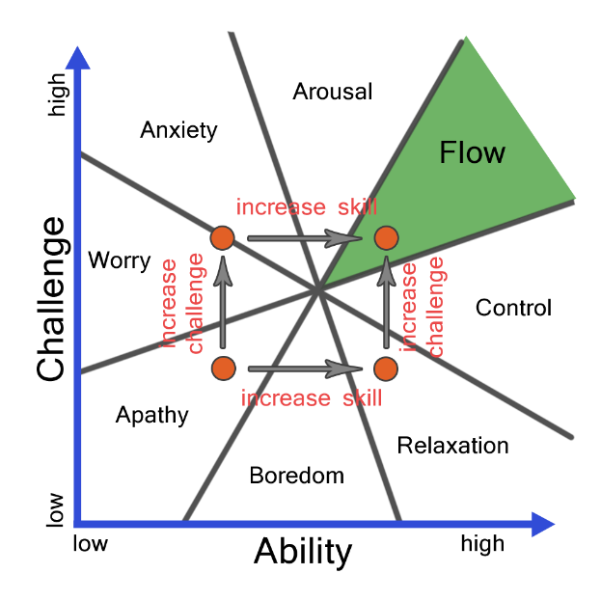
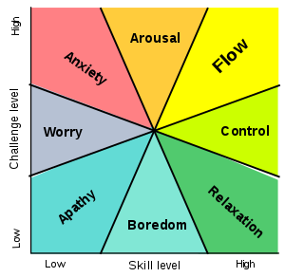

Depending on the task, using your state of flow can increase productivity. By completing the task in one sitting and taking a break after, it can help to finish the task quicker by keeping mental focus rather than taking scheduled breaks throughout.

Flowtime Steps
- To begin, select a single task to work on, this is called unitasking
- Track how long it takes you to complete the task, include start time, end time and the number of interruptions (this can help you reduce interruptions and distractions in the future)
- Take a break! Here are break time suggestions:
  - For 25 minutes of work or less, take a five-minute break.
  - For 25-50 minutes of work, take an eight-minute break.
  - For 50-90 minutes of work, take a 10-minute break.
  - For more than 90 minutes of work, take a 15-minute break.

Flowtime Example
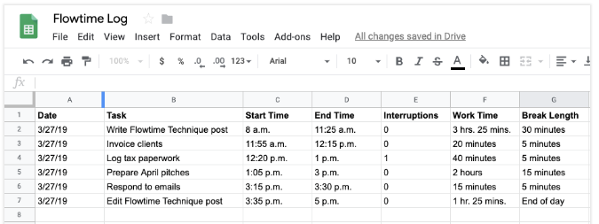

Date | Task | Start Time | End Time | Interruptions | Work Time | Break Time
Flowtime Chart

References:
https://medium.com/@lightsandcandy/the-flowtime-technique-7685101bd191
https://zapier.com/blog/flowtime-technique/
Say no to Procrastination

