Test Anxiety

It’s common to be anxious before taking a test and some amount of anxiety is a good thing, but having too much anxiety can distract you.

Test anxiety is like forgetting the password to your computer; the information is there, but you can’t retrieve it. Keep in mind that the long-term memory can hold an unlimited amount of information, the working memory is limited to both duration and capacity. During an exam, information must be retrieved from long term memory to working memory. Anxiety, coupled with small working memory capacity, can lead to poor processing abilities and negatively affect performance.

Here are some common signs of test anxiety:

- Physical: you fidget, pace, sweat excessively, feel your heart race or abuse substances before a test
Health: you experience headaches, nausea, dry mouth, or frequent urination before a test
- Mental: you think “I am stupid” or “I can’t do this,” feel overwhelmed, suddenly forget the answers right before the test, or score much lower than you do on homework or papers

Tips to reduce test anxiety:

- Create a study schedule and stick to it. If you are well prepared, this will decrease your anxiety. Make sure to stay organized, ask your professor about difficult concepts, and study with a group.

- Take a few minutes to write down your thoughts and feelings about the test’s content. Writing down your thoughts alleviates worry and helps you focus.

- Walk into the test with your head up and shoulders back. The more confident you act, the more confident you will feel.

- Use relaxation techniques:

- Breathing: Take a deep breath, hold for four seconds, then slowly breathe out, releasing any tension. Repeat until you feel relaxed.

- Muscle relaxation: Starting with the top of your head, flex and relax each part of your body.

- Visualization: Close your eyes and envision warm sunshine washing over you, melting away tension and relaxing you. Or, imagine a place where you feel relaxed and calm.

The “What if” factor: Another way to reduce anxiety is to counter the ANTS (Automatic Negative Thoughts) and “What ifs” that you are thinking, which add to anxiety. For example, you may think:

What if I….
Don’t know the answer to some of the questions on the exam

then I…
Will fail the exam
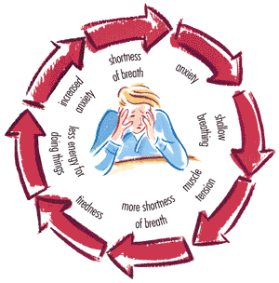

And then…
I will fail the class

and then…
I will drop out of USC

and then…
I will not be able to get a job

Evaluate:

- Which events are realistic?

- How much of an issue would it actually be?

- Are you over generalizing? Discounting the positives? Jumping to conclusions?

Source: O'Brien, Linda . How to Get Good Grades in College . Dayton, OH: Woodburn Press , 2008. Print.

