Make Your Own Hot Pack

Benefits of a Hot Pack
- Provides relief to tense, sore, or tight muscles
- Provides pain relief
- Increases the relaxation response

How to Make a Hot Pack
Hot packs are a great way to provide relief to your tense muscles after a long study session. A hot pack can also be incorporated into a quick 5-minute study break. If you have essential oils on-hand, you can add it to the contents of your hot pack to activate your olfactory senses. Taking a moment to relax and smell the different scents can help you to ground yourself and be present-focused. Depending on the type of essential oil you add to your hot pack, it can help to increase your focus or decrease your stress. If you do not have essential oils, you can make the hot pack without it! Here’s how to make your own hot pack!

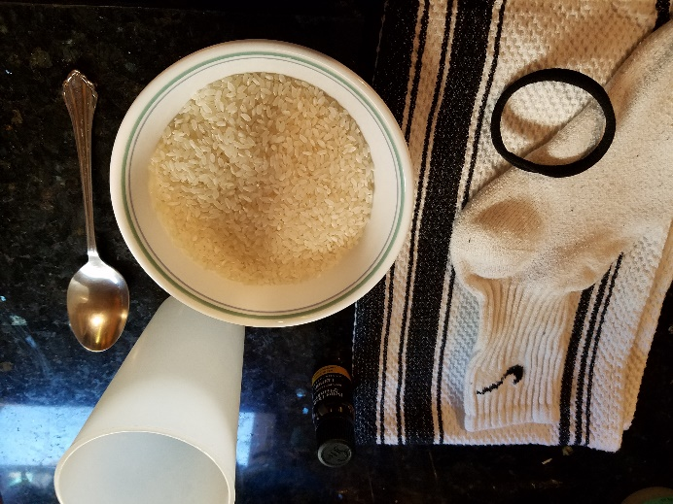
Materials Required:
- Clean sock
- Uncooked rice* (or uncooked beans/uncooked steel cut oats)
- Tie (i.e. rubberband, hair tie without metal piece, sewing thread and needle)
- Tall cup
- Bowl
- Spoon
- Clean towel
- Microwave (not pictured)

Steps-by-step guide on how to make a hot pack:
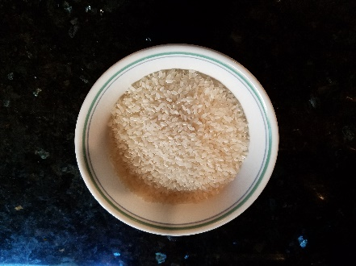
1. Pour uncooked rice into a bowl.
(Pictured: ~2 cups of uncooked rice)

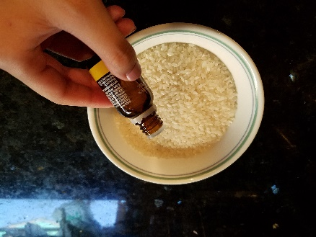
2. Add a few drops of essential oil to the uncooked rice.
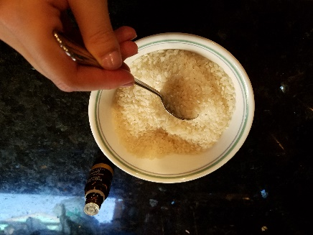
3. Mix the contents in your bowl together with the spoon.
          - The amount of scent is personal preference depending on how strong you want the scent.

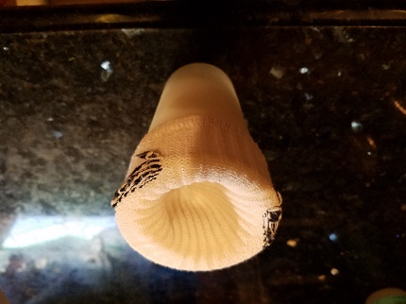
4. Place your clean sock inside the tall cup and pull the edge of the sock around the lip of the cup (this helps to keep the sock open as you fill it with rice).

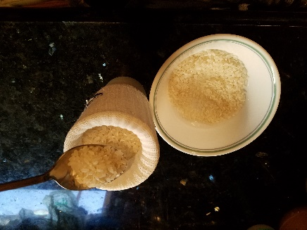
5. Using the spoon, fill the sock until it is ½ - ¾ full of the scented, uncooked rice.
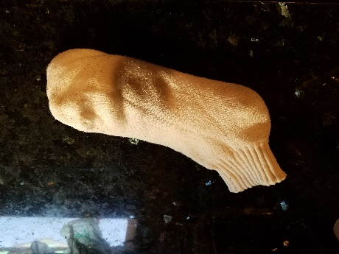
6. Remove the filled sock from the cup.
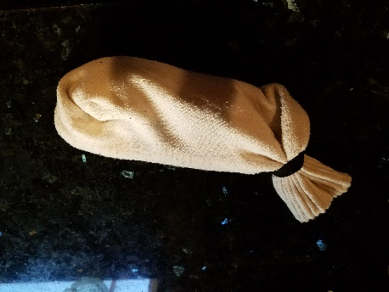
7. Tie a knot at the opening of the sock so rice does not escape.
          - You can use a rubber band or a hair tie without metal to tie your sock shut.
          - If you have sewing equipment, such as a needle, thread or a sewing machine, you can also sew your sock shut.

Steps-by-step guide on how to use the hot pack:
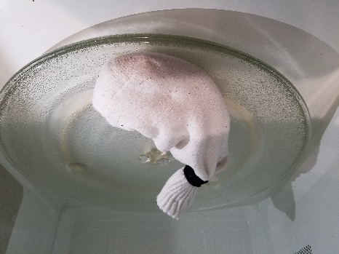

- Place the hot pack sock in the microwave and microwave the sock for ~1 minute.
a. The hot pack should be warm to the touch.

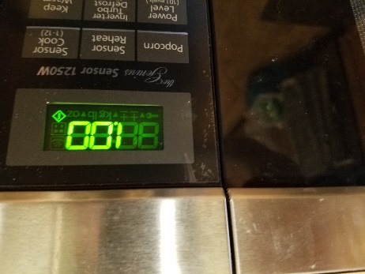
- If the hot pack is not hot enough after 1 minute, microwave in additional 30 second intervals.
            - Check the hot pack after each 30 seconds.
            - The amount of time to heat the hot pack will vary depending on the amount of uncooked rice you used and the power of the microwave.

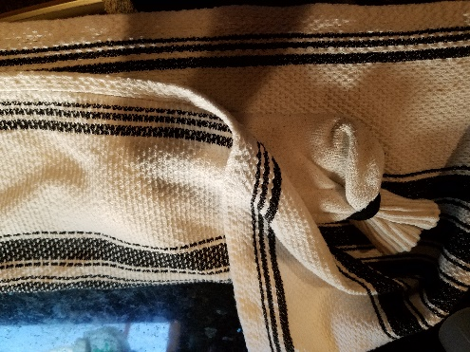
3. Wrap the hot pack with a clean towel so there is a layer of towel between the hot pack and your skin.

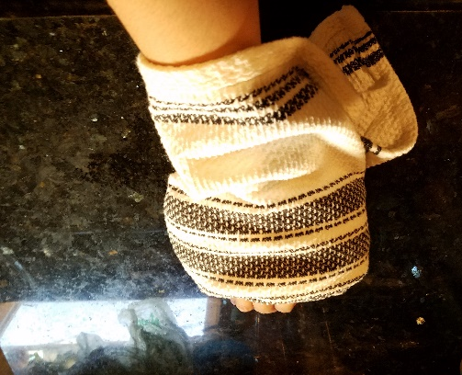
4. Apply the hot pack to your tense, tight muscles for 10 minutes.
            - You can put the hot pack on your neck, shoulder, arm, wrist, hand, or any muscles that is tense or sore.
            - If you are lying down, you can put the hot pack on tight upper or lower back muscles.

5. If you feel the hot pack it too hot or if your skin visibly turns red, remove the hot pack and let it cool down a bit before reapplying.
  - You can also add more layers of towel between the hot pack and your skin.

6. The hot pack can be re-heated as many times as you may need it. Check the tied end of your hot pack occasionally to ensure that the filling does not fall out.

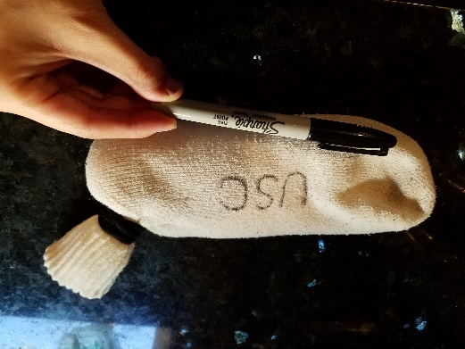
7. Decorate your hot pack with permanent marker.

You should not use a hot pack if you have:
- Impaired sensations
- Impaired blood circulation
- Bleeding tendencies
- Tumors or cancer
- Rheumatoid arthritis
- Infection
- Open wounds

Research
The authors found that HSG (heat and steam generating) sheets placed on the neck significantly decreased fatigue and neck stiffness. The sheets also increased parasympathetic activity, or the relaxation response, and inhibited sympathetic activity. The relaxation response helps to decrease stress (Yasui et al., 2010).
Additional Resources for Benefits of Aromatherapy
Sensory Strategies for Wellness handout on KCLC website;
- Increase focus
  - Eucalyptus
  - Lemongrass
  - Mint
- Decrease Stress
  - Chamomile
  - Lavender

References
Bracciano, A. G. (2008). Physical Agent Modalities: Theory and Application for the Occupational Therapist (2nd Ed.). New Jersey: SLACK Incorporated.
Yasui, H., Takamoto, K., Hori, E., Urakawa, S., Nagashima, Y., Yada, Y., Ono, T., & Nishijo, H. (2010). Significant correlation between autonomic nervous activity and cerebral hemodynamics during thermotherapy on the neck. Autonomic Neuroscience, 156(1), 96-103.

