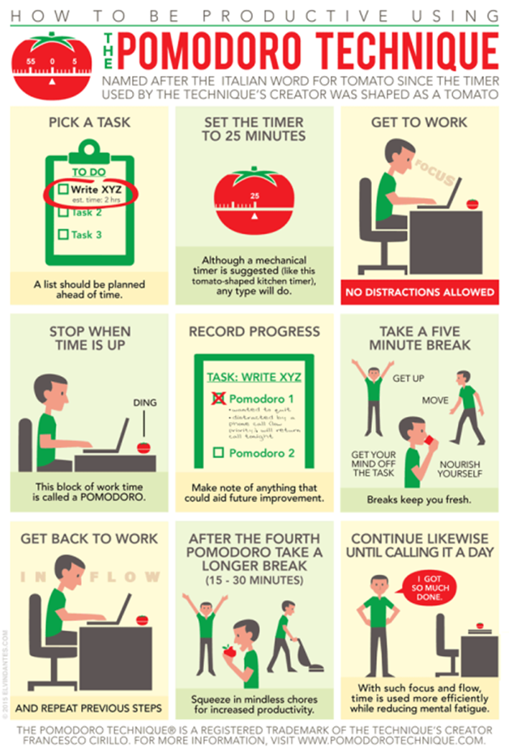
 | Session 1 | Session 2 | Session 3 | Session 4
Pomodoro #1
Pomodoro #2
Pomodoro #3
Pomodoro #4
15 Minute Break

Pomodoro Apps:

Focus To-Do (Free)
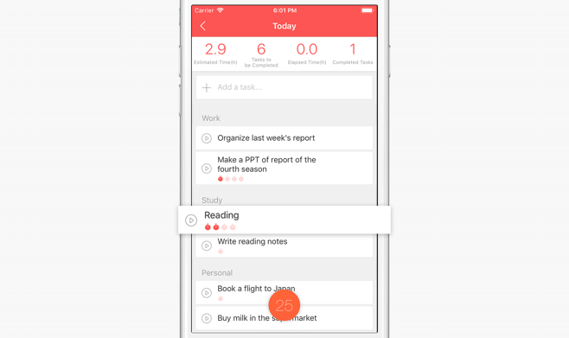

Goodtime (Free)
