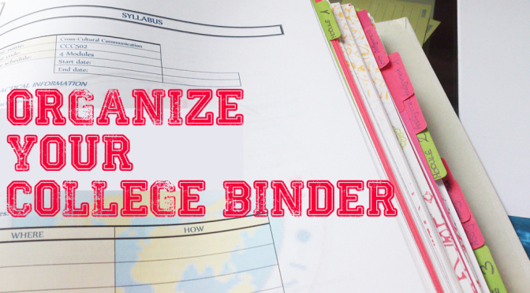

***Organizing Your Assignments 101***

* When an assignment is given out in class, read the instructions carefully.
* Ask the professor for any clarification.
* Break the task down into smaller chunks.
* Plan out when you will tackle each part of the assignment.
* Give yourself more time in completing the assignment than you think it will take.
* When you have completed the assignment, proofread and edit to your satisfaction.
* Ask the professor or TA if they can check your assignment and provide feedback before the due date.

***Organizing Your Time 101***

* Schedule activities in your agenda or calendar, hour by hour.
* Block off when you are in class or have commitments.
* Record all school-related tasks on a separate document for each subject.
* Schedule time to complete each task.
* Input downtime for breaks and unexpected occurrences.
* Stick to your schedule as much as possible, though allow for adjustment and flexibility when required.

***Organizing Your Binders 101***

* Designate one binder for each course.
* Put dividers into your binders.
* Label each tab accordingly, based on the course.
* Date each document received and place it in the appropriate section of the binder.
* Keep binders in a set place and label each spine.

Student Organization