How to Organize your Backpack

Tired of losing your things within the dark abyss of your backpack?
Try these backpack hacks to be more organized, have less clutter, increase your efficiency and reduce your stress!

✓ Utilize all backpack compartments and create a “home” for each item
✓ Sort items from biggest to smallest (i.e. laptop, notebook, planner, pencil case, etc.)
✓ Avoid placing loose paper inside backpack (use binders or file folders)
✓ Use lanyards to easily locate keys and ID cards
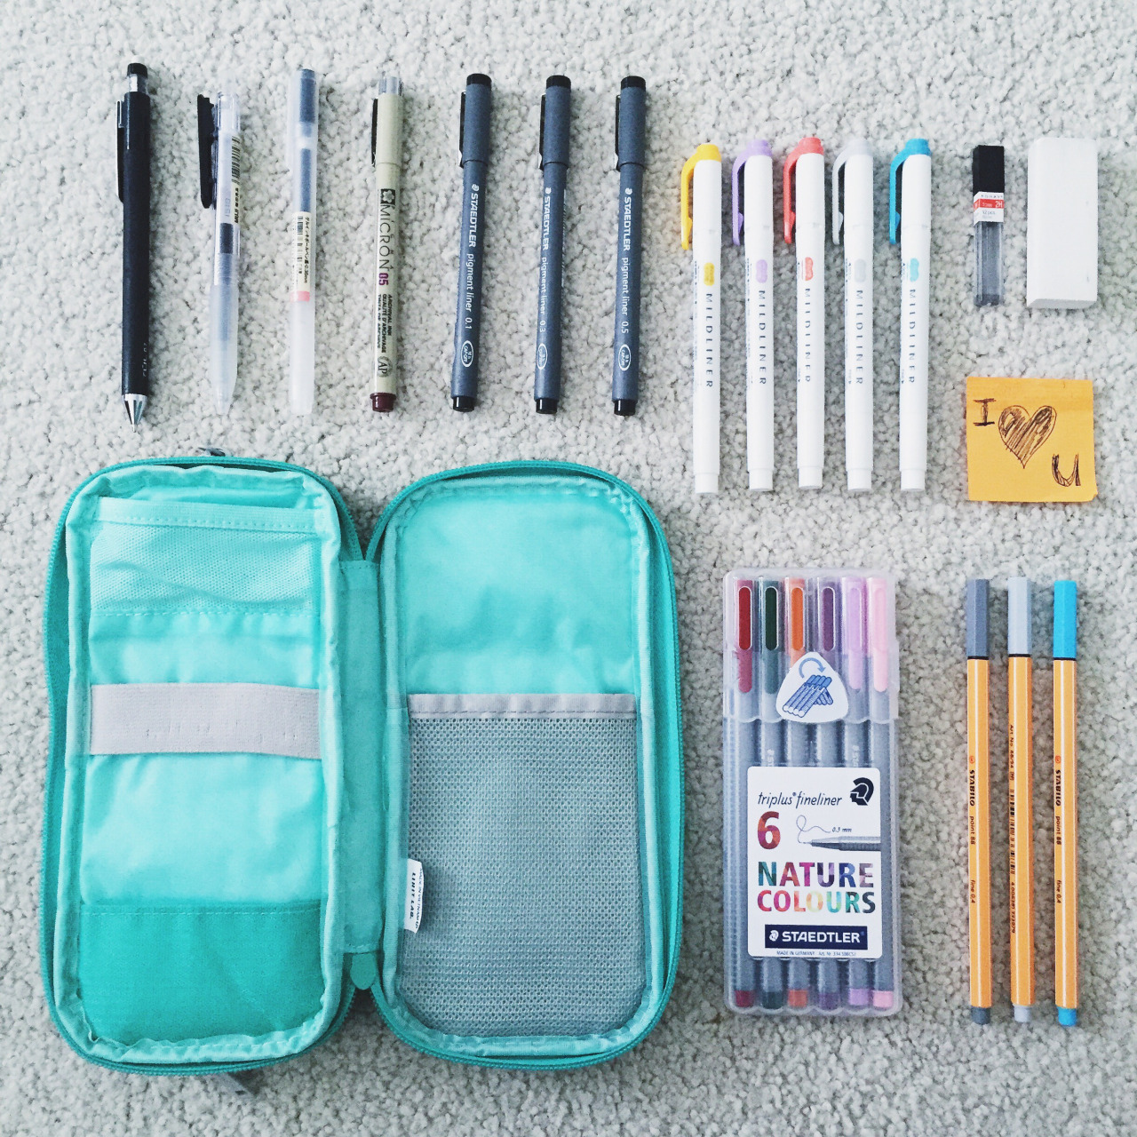
✓ Keep pencils, pens, & highlighters in a pencil case
✓ Place receipts in wallet or small folder organizer
✓ Use smaller boxes or bags for smaller supplies (i.e. post-its, erasers, stapler, tape, paper clips, etc.)
✓ Remember to zip-up backpack
✓ Obtain a hole puncher for 3-ring binders
✓ Keep a small emergency kit inside backpack (i.e. Band-Aids, hand sanitizer, chap stick, medicine, gum, tissues, a non-perishable snack, etc.)
✓ Carry reusable water bottles and utilize outside pockets to store them
✓ Create a habit of placing your backpack in the same location at home

Contributing KCLC writer: Christina N. Rivas

