5 Ways to Organize Your Dorm Space
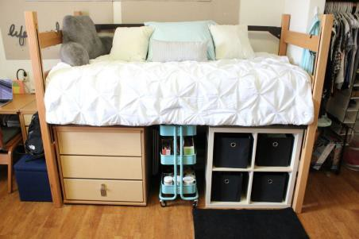
- Utilize the Space Under the Bed | This area can be used for a variety of purposes to store laundry, drawers, plastic bins, shelves, etc.
- Sort and Save Space in Drawers | De-clutter your dresser drawers and sort your clothes or school supplies with dividers!
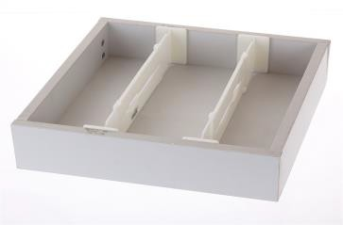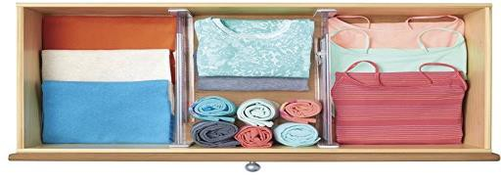

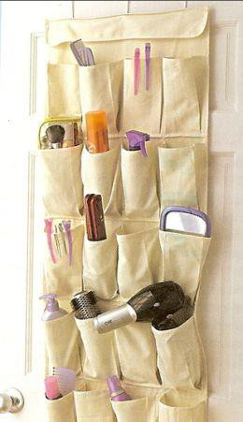
- Multipurpose Shoe Hanger | Use a shoe hanger miscellaneous storage needs! Store anything ranging from shoes, food, makeup, and cleaning supplies.

- Shower Curtain Links | Place shower curtain links on a hanger to hold tank tops, hats or scarves.

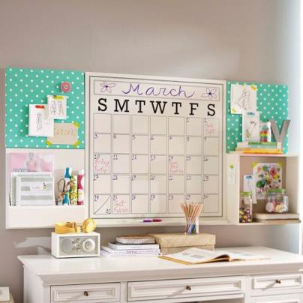
- Desk/Wall Calendar | Have a calendar in your room to keep track of important events and major assignments.

Contributing KCLC writer: Christina N. Rivas

