**3. REVIEW**

When you review, you lock the information into your brain before it has a chance to evaporate.

To Review:

1. Answer out loud the questions that you generated from the headings.
2. Reread the **boldfaced** subtitles and *italicized* words, briefly restating the purpose to yourself using your own words.
3. If your textbook has review questions, go over them & make sure that you know all of the answers.
4. Consider summarizing or outlining the material.

**2. READ**

When your reading has a purpose:

* your comprehension improves
* it’s easier to stay focused
* you can identify important information

To become an ACTIVE reader:

1. Turn the headings and subtitles into questions.
2. Keep your question in mind when you read so that your mind will not wander.
3. Look for any vocabulary words, names, places, or events in **bold** or *italic* print.
4. Ask yourself “Why is this word, person, place, or event important? Which sentences state the main idea? What is the author trying to tell me?”
5. At the end of the section, you should be able to answer your questions & identify why the terms are important.
6. **SCAN**

Scanning gives you a quick overview of the material that you are going to be reading. It provides a framework of topics & main ideas that will make it much easier for you to read, understand & remember the more detailed information.

To Scan:

1. Preview the chapter by reading the title, subtitles, everything in **bold** & *italic* print.
2. Look at all of the pictures, charts, & diagrams & their accompanying description.
3. Read the introduction, review questions, & the summary before reading the main sections.

*Diagram Examples*

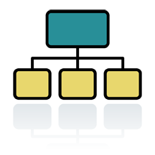*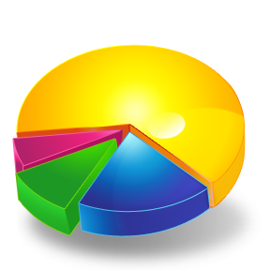C:\Users\cas-stu\AppData\Local\Microsoft\Windows\Temporary Internet Files\Content.IE5\9S1NXRHD\MC900237272[2].wmf*