Test Anxiety
Everyone gets anxious before taking a test and some amount of anxiety is a good thing! However, having too much anxiety can distract you, lowering your score on an exam. Here are some common signs of test anxiety:

- Physical: you fidget, pace, sweat excessively, feel your heart race or abuse substances before a test.
- Health: you experience headaches, nausea, dry mouth, or frequent urination before a test.
- Mental: you think “I am stupid” or “I can’t do this”, go blank, feel overwhelmed, suddenly know the answers after turning the test in, or score much lower than you do on homework or papers.

Tips to reduce test anxiety:

- Create a study outline and stick to it. If you are well prepared, this will decrease your anxiety. Make sure to stay organized, ask your Professor about difficult concepts, and study with a group.

- Visualize yourself going through the testing experience. See yourself walking into the classroom confidentially, taking the test with ease, and earning the grade you want.

- Walk into the test with your head up and shoulders back. The more confident you act, the more confident you feel.
- Use relaxation techniques:
- Visualization: Close your eyes and envision warm sunshine washing over you, melting away tension and relaxing you. Or, imagine a place where you feel relaxed and calm.

- Muscle relaxation: Starting with the top of your head, flex and relax each part of your body.

- Breathing: Take a deep breath, hold for four seconds, then slowly breathe out, releasing any tension. Repeat until you feel relaxed.

The “What if” factor: Another way to reduce anxiety is to counter the ANTS (Automatic negative thoughts) and “What ifs” that you are thinking, which add to anxiety. For example, you may think:

What if I….
Don’t know the answer to some of the questions on the exam

then I…
Will fail the exam
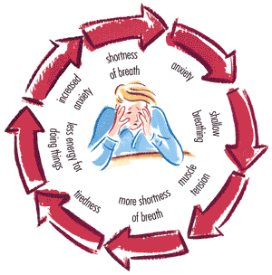

And then…
I will fail the class

and then…
I will drop out of USC

and then…
I will not be able to get a job

Evaluate:

- Which events are realistic?

- How much of an issue would it actually be?

- Are you over generalizing? Discounting the positives? Jumping to conclusions?

